IMPLEMENTATION:
What happens after signature?
—

We know that switching from a legacy PPE is a project in and of itself, and that today’s challenging market environment creates even more uncertainty. The market has headwinds and we are here to help lenders navigate through it and ultimately capitalize on the downtime to prepare for a future when the housing market is hot again. When the mortgage industry reaches the light at the end of the tunnel, lenders who invest internally now will be positioned to take on soaring demand and retain talented teams.

Our customer partners are Polly’s main priority and focus. Further, we recognize the importance of transparency and open communication throughout the implementation and onboarding process – and beyond. That is why we have made a deep investment in both to ensure we facilitate your success throughout this process. There is nothing more important to us than your satisfaction and our team is here to guide you every step of the way.

Key takeaways

- Now is the time: Current market conditions have granted lenders the perfect opportunity to evaluate and adopt world-class software.
- Polly works at your speed: Fully tailored to your unique preferences and needs, we accommodate a rollout based on your specific timeline and degree of urgency.
- Built with simplicity in mind: Users benefit from an intuitive UI and clear-cut workflows. Training is minimal and LOs are quickly confident in their new capabilities.
- Quick implementation timeline: Polly’s implementation and onboarding was designed with an emphasis on ease and efficiency.
- 90% of the onboarding and implementation is managed by Polly: Zero IT deployment is required on the customer partners’ end.
- Dedicated points of contact: A dedicated Product Solution and Implementation Specialist are assigned to each account and are readily available for questions, general feedback, and assistance throughout the implementation process.

Implementation kickoff
The contract has been signed; welcome to Polly! Below is a quick outline of what comes next.

- A countersigned contract is delivered.
- The company account is assigned to an Implementation Consultant. This will be the customer’s dedicated point of contact throughout the implementation process.
- A call is coordinated between internal Polly teams (Sales and Customer Success) to go over details specific to that company account.
- The Implementation Consultant sends a welcome email to the customer with a request to identify their list of investors and LOS instance ID, and send it back to Polly.
- After the investor list and LOS instance ID are received, a kickoff call is scheduled to discuss the implementation and onboarding process in detail.

Post kickoff call: Alignment on requirements
This is where the implementation process really begins. Polly is dedicated to making this transition as easy as possible, providing you with the guidance and training to ensure you are successful. What does this mean for the lender? During implementation, Polly will provide consultative guidance on how to configure guidelines and pricing for any and all custom products the lender may offer. This will be discussed in detail with your dedicated Implementation Consultant (see next section).

Getting started

- If a customer is on Encompass, Polly will need their Encompass Instance ID.
- From there, we will request an Encompass API key from ICE Mortgage Technology.
- Once the API token is received from ICE Mortgage Technology (usually within a week), Polly will integrate the customer’s site with Encompass.
- In ongoing implementation calls, the customer will need to provide Polly with applicable products and channels, their NMLS ID, any secondary lock desk policies, margin policies, post-lock policies, any products marked hedged, or other details related to their preferred configuration and setup.
- Have a locked pipeline already in place? Ask us about our pipeline migration tool.

Next steps for Polly: Configuration
Throughout implementation, your dedicated Implementation Consultant will coordinate regular weekly project calls focused on overall implementation delivery. In addition to these structured updates, they will continue to collaborate closely with your team on product configuration, testing, and ongoing consultation to ensure a successful launch.

- A weekly call is scheduled with the customer, which serves as a recurring check-in on the progress of implementation and testing. This is also the ideal time to ask any questions or make necessary adjustments throughout implementation. Weekly tasks are tracked in checklist form, as shown in the example below.
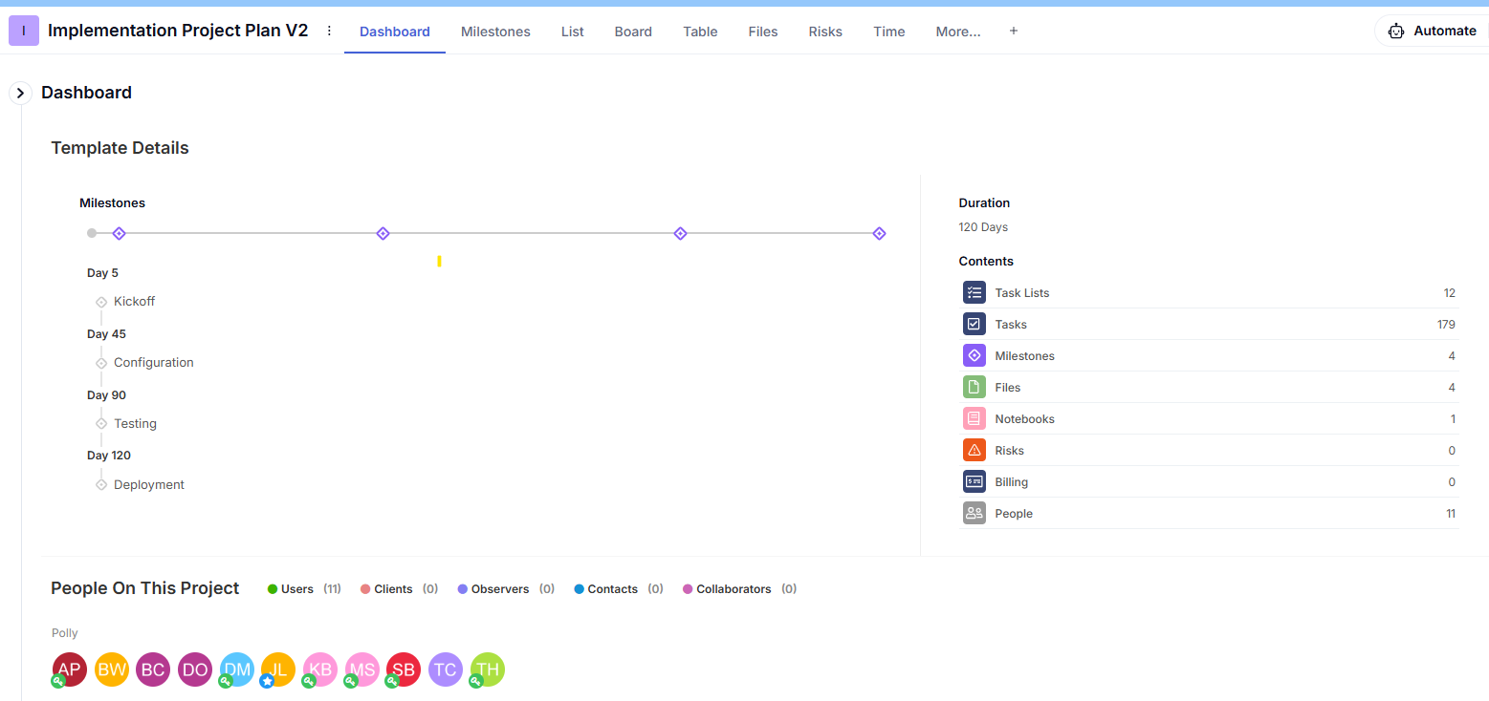
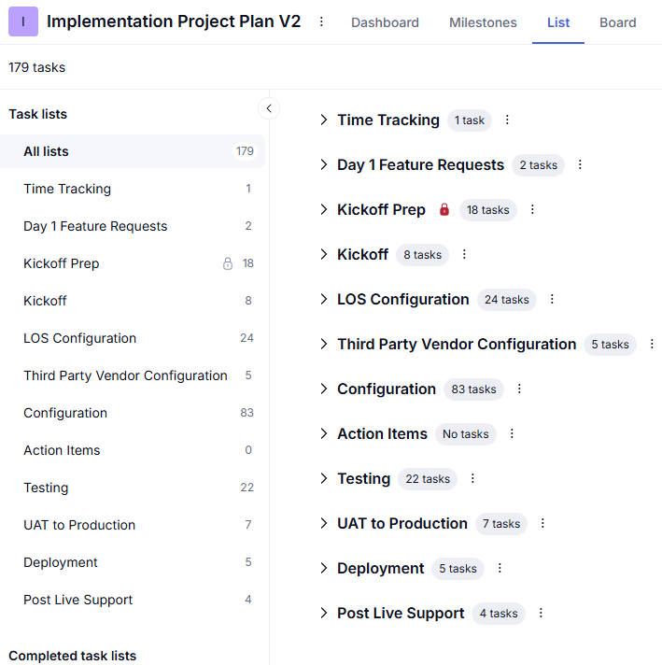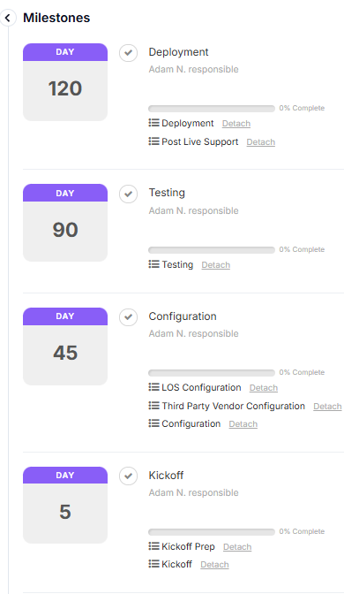
- The Implementation Consultant will work hand-in-hand with you to configure the PPE instance, adding investors and products, as well as all margin, initial- and post-lock policies.
- In addition, Polly will provide consultative guidance and hands-on support to ensure all necessary pricing channels are configured and any applicable products are updated to include delivery pads, extended lock options, or hedged designations as needed.

Post-site setup: Testing and training
Your new PPE instance is ready; let the training begin.

- The recurring weekly calls will now transition to a training format and each week will cover a different topic.
  - Loan officer training: Typically, one 45-minute session is required to get LOs comfortable with their new capabilities in Polly.
  - Lock desk/secondary training: Scheduled weekly, these 30-minute sessions include an agenda tailored to your organization and teams. Our goal is to help ensure that all capital markets, secondary, and lock desk teams experience the full scope of capabilities within the system and have the opportunity to ask questions specific to your unique business use case.
- Each week, Polly will ask you to complete specific testing of the integration, products and pricing, as well as review of the setup/configuration.
Prompt and thorough testing is vital to keep the implementation timeline on track.
- Polly will also request that each customer review the Pricer UI and provide any feedback, which we will use to tailor the look and feel to the LO experience you desire.
- If a customer is on Encompass, Polly will coordinate a call to assist in setting up users in Encompass Partner Connect (EPC).

Final steps
The site is configured, you have completed testing, and everything is running smoothly.

- At this point, Polly and the customer will align on a rollout/go live date, discuss the rollout plan that will allow for optimal success, and schedule LO training.
  - NOTE: The rollout plan can be fully tailored to your preference. Some lenders choose to do a slow rollout where they start with select branches, while others prefer to have all users rollout at the same time. We encourage you to discuss the options with your Implementation Consultant and choose the approach that you feel most comfortable with.
- Once live, your Implementation Consultant will continue to meet with you on a weekly basis and also manage any day-to-day requests until the implementation is stable and your team is ready for a smooth transition to your Customer Success Manager.
- Once your team is comfortable using the system, you’ll be encouraged to direct any questions to the Polly Help Desk for timely assistance. Behind the scenes, your full Polly team will remain connected to ensure a smooth and well supported experience.

Referrals
Don’t just take our word for it. If you would like to further discuss the implementation process with a lender that has already experienced it, please request a referrals list.

